Erik MARRERO

10/15/2020

public class postfix

{

// A utility function to return precedence of a given operator

// Higher returned value means higher precedence

static int Prec(char ch)

{

switch (ch)

{

case '+':

case '-':

return 1;

case '*':

case '/':

return 2;

case '^':

return 3;

}

return -1;

}

// The main method that converts given infix expression

// to postfix expression.

static Queue<Character> infixToPostfix(String exp)

{

Queue<Character> store = new Queue<>();

for (char a : exp.toCharArray()) {

store.enqueue(a);

}

// initializing empty String for result

//String result = new String("");

Queue<Character> result = new Queue<>();

// initializing empty stack

Stack<Character> stack = new Stack<>();

for (int i = 0; i<exp.length(); ++i)

{

char c = store.dequeue();

// If the scanned character is an operand, add it to output.

if (Character.isLetterOrDigit(c))

result.enqueue(c);

// If the scanned character is an '(', push it to the stack.

else if (c == '(')

stack.push(c);

// If the scanned character is an ')', pop and output from the stack

// until an '(' is encountered.

else if (c == ')')

{

while (!stack.isEmpty() && stack.peek() != '(')

result.enqueue(stack.pop());

if (!stack.isEmpty() && stack.peek() != '(')

return null; // invalid expression

else

stack.pop();

}

else // an operator is encountered

{

while (!stack.isEmpty() && Prec(c) <= Prec(stack.peek())){

if(stack.peek() == '(')

return null;

result.enqueue(stack.pop());

}

stack.push(c);

}

}

// pop all the operators from the stack

while (!stack.isEmpty()){

if(stack.peek() == '(')

return null;

result.enqueue(stack.pop());

}

return result;

}

// Method to evaluate value of a postfix expression

static int evaluatePostfix(String exp)

{

//create a stack

Stack<Integer> stack=new Stack<>();

// Scan all characters one by one

for(int i=0;i<exp.length();i++)

{

char c=exp.charAt(i);

// If the scanned character is an operand (number here),

// push it to the stack.

if(Character.isDigit(c))

stack.push(c - '0');

// If the scanned character is an operator, pop two

// elements from stack apply the operator

else

{

int val1 = stack.pop();

int val2 = stack.pop();

switch(c)

{

case '+':

stack.push(val2+val1);

break;

case '-':

stack.push(val2- val1);

break;

case '/':

stack.push(val2/val1);

break;

case '*':

stack.push(val2*val1);

break;

}

}

}

return stack.pop();

}

// Driver method

public static void main(String[] args)

{

String exp = "53*682/";

System.out.println("Infix: "+ exp);

System.out.print("Postfix: ");

Queue<Character> ans = infixToPostfix(exp);

if (ans == null) {

System.out.println("Invalid Expression");

}

else {

ans.display();

}

try {

System.out.println("\npostfix evaluation: "+evaluatePostfix(exp));

}

catch(NullPointerException e) {

System.out.println("NullPointerException thrown!");

}

}

}

import static java.lang.System.exit;

// Create Stack Using Linked list

public class Stack<E> {

// A linked list node

private class Node {

E data; // integer data

Node link; // reference variable Node type

}

// create global top reference variable global

Node top;

int size=0;

// Constructor

public Stack()

{

this.top = null;

}

// Utility function to add an element x in the stack

public void push(E x) // insert at the beginning

{

// create new node temp and allocate memory

Node temp = new Node();

size++;

// initialize data into temp data field

temp.data = x;

// put top reference into temp link

temp.link = top;

// update top reference

top = temp;

}

// Utility function to check if the stack is empty or not

public boolean isEmpty()

{

return top == null;

}

// Utility function to return top element in a stack

public E peek()

{

// check for empty stack

if (!isEmpty()) {

return top.data;

}

else {

System.out.println("Stack is empty");

return null;

}

}

// Utility function to pop top element from the stack

public E pop() // remove at the beginning

{

// check for stack underflow

if (top == null) {

System.out.print("\nStack Underflow");

return null;

}

// update the top pointer to point to the next node

Node temp = top;

top = (top).link;

size--;

return temp.data;

}

public void display()

{

// check for stack underflow

if (top == null) {

System.out.printf("\nStack Underflow");

exit(1);

}

else {

Node temp = top;

while (temp != null) {

// print node data

System.out.printf("%d -> ", temp.data);

// assign temp link to temp

temp = temp.link;

}

}

}

public int size() {

return size;

}

public static void main(String[] args)

{

// create Object of Implementing class

Stack<Integer> obj = new Stack<Integer>();

// insert Stack value

obj.push(55);

obj.push(34);

obj.push(98);

obj.push(4);

// print Stack elements

obj.display();

// print Top element of Stack

System.out.printf("\nTop element is %d\n", obj.peek());

// Delete top element of Stack

obj.pop();

obj.pop();

// print Stack elements

obj.display();

// print Top element of Stack

System.out.printf("\nTop element is %d\n", obj.peek());

}

}

import static java.lang.System.exit;

// A class to represent a queue

// The queue, front stores the front node of LL and rear stores the

// last node of LL

public class Queue <E>{

private class QNode {

E key; // integer data

QNode next; // reference variable Node type

public QNode (E k) {

key = k;

}

}

// create global top reference variable global

QNode front, rear;

int size=0;

public Queue()

{

this.front = this.rear = null;

}

// Method to add an key to the queue.

void enqueue(E key)

{

// Create a new LL node

QNode temp = new QNode(key);

size++;

// If queue is empty, then new node is front and rear both

if (this.rear == null) {

this.front = this.rear = temp;

return;

}

// Add the new node at the end of queue and change rear

this.rear.next = temp;

this.rear = temp;

}

// Method to remove an key from queue.

public E dequeue()

{

// If queue is empty, return NULL.

if (this.front == null)

return null;

// Store previous front and move front one node ahead

QNode temp = this.front;

this.front = this.front.next;

size--;

// If front becomes NULL, then change rear also as NULL

if (this.front == null)

this.rear = null;

return temp.key;

}

public E first() {

return front.key;

}

public int size()

{

return size;

}

public void display()

{

if (front == null) {

System.out.printf("\nStack Underflow");

exit(1);

}

else {

QNode temp = front;

while (temp != null) {

System.out.print(temp.key);

temp = temp.next;

}

}

}

public static void main(String[] args)

{

Queue<Integer> q = new Queue<Integer>();

q.enqueue(20);

q.enqueue(30);

q.dequeue();

q.dequeue();

q.enqueue(40);

q.enqueue(50);

q.enqueue(60);

q.dequeue();

System.out.println("Queue Front : " + q.front.key);

System.out.println("Queue Rear : " + q.rear.key);

}

}

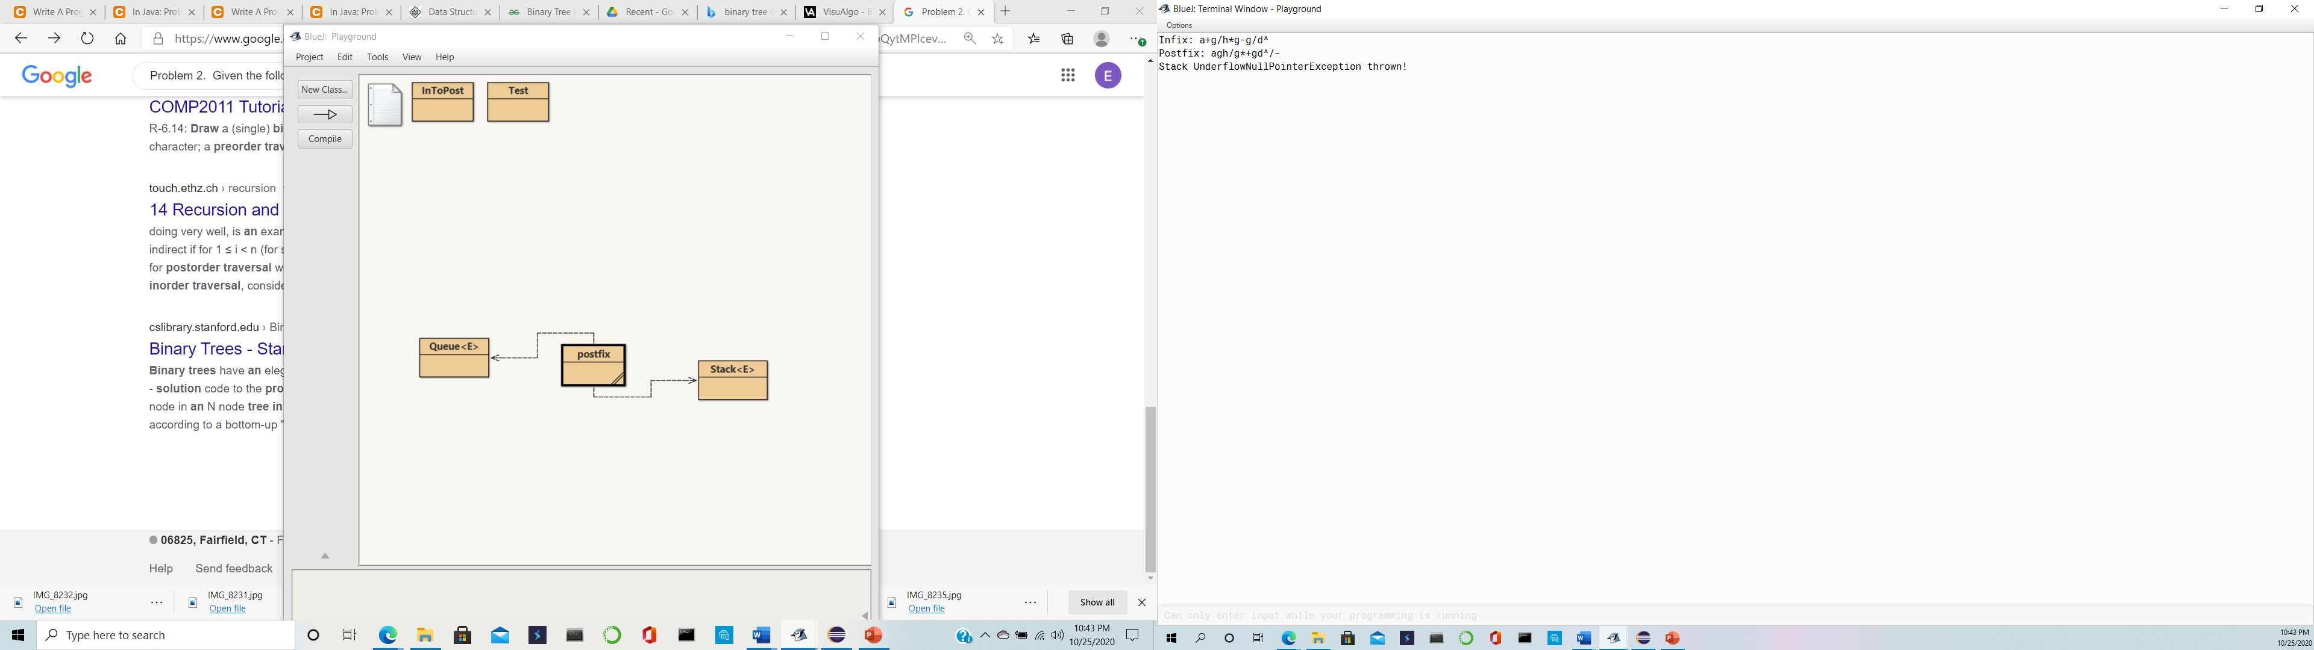

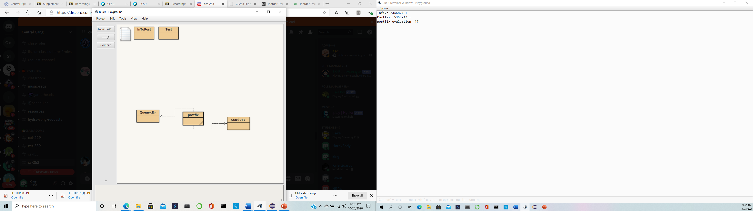

Question 2:

1.

Find the last node in post order array and make it the root

2 Then Search for the last node in order array

--Note that everything on the left of above node in the inorder array is left subtree and remaining on right is the right subtree

3. we repeat the same process for newly formed left subtrees and right subtrees

4. we implement the same thing recursively

We follow the rule left visit and right if no more left then output and try and go right if no more go back.You move left to right. So since you cant go left any more after c, c gets output then you go to b and output b as well as a, so you have CBA Then you go to e and it gets output then d. then we have CBAEDF And so on until you get CBAEDFHIGK as shown in the pictures.The Last element in the *postorder* will be the *root* of the tree, here it is H.Now the search ele­ment H in *inorder*, say you find it at posi­tion H, once you find it, make note of ele­ments which are left to *H* (this will con­struct the left­sub­tree) and ele­ments which are right to *H* ( this will con­struct the rightSubtree).Suppose in previous step, there are X number of elements which are left of ‘*H’* (which will construct the leftsubtree), take first X elements from the postorder traversal, this will be the post order traversal for elements which are left to *H* similarly if there are Y number of elements which are right of ‘H’ (which will construct the rightsubtree), take next Y elements, after X elements from the postorder traversal, this will be the post order traversal for elements which are right to *H.*From previous two steps construct the left and right subtree and link it to root. Left and root. right respectively

Postorder : ABCDEFGHIKJGH

Inorder:CBAEDFHIGKJ

Steps:

Get root h

1. Select the last node which is H and it is the root from inorder.

H becomes the main root. C,B,A,E,D,F become the left subtree/ child and (I,G,K,J) become the right subtree/ child

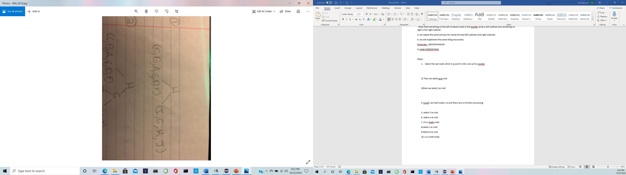

2) Then we select g as root.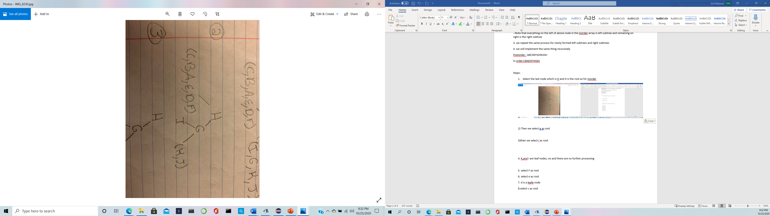

3)then we select j as root

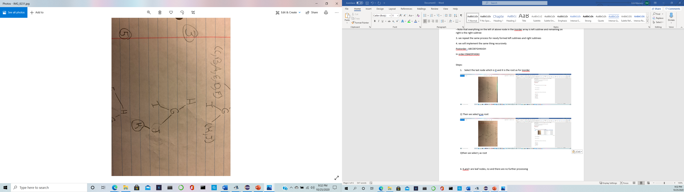

4. K,and I are leaf nodes, there is no further processing

5. select F as root

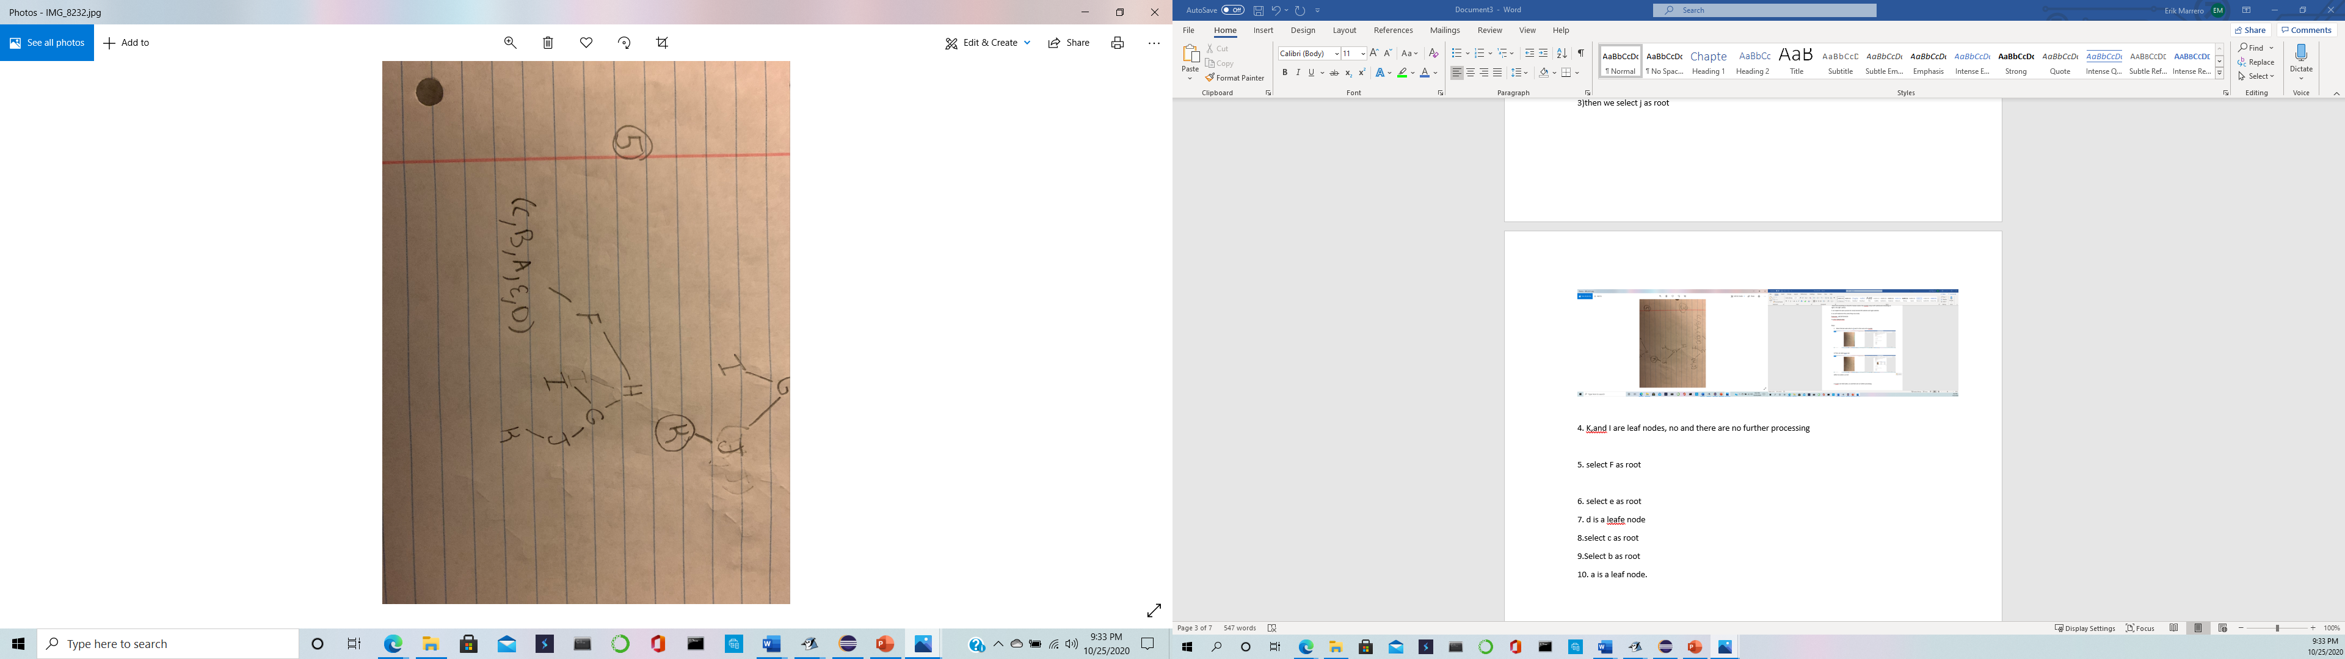

6. select e as root

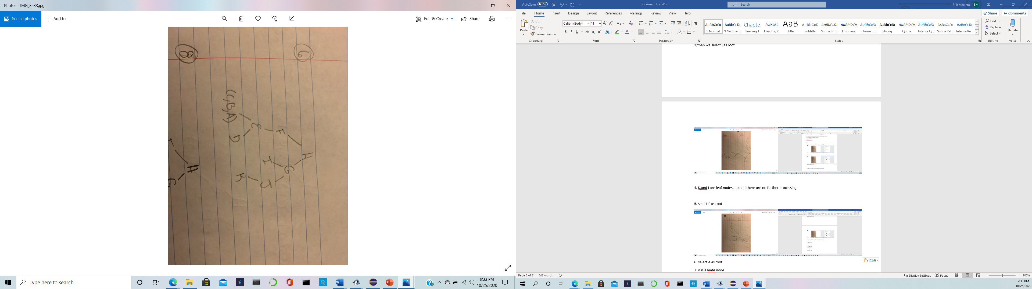

7. d is a now a leaf node

8.Then we select c as root

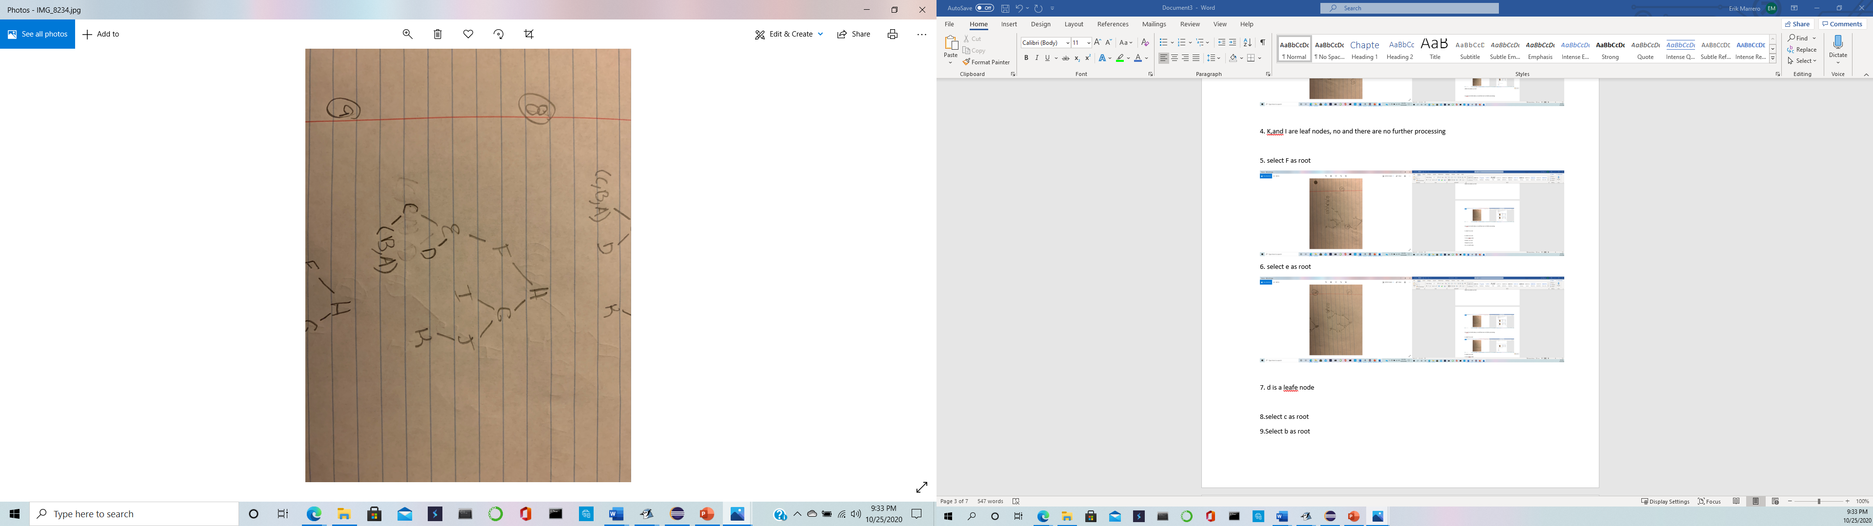

9.Select b as root

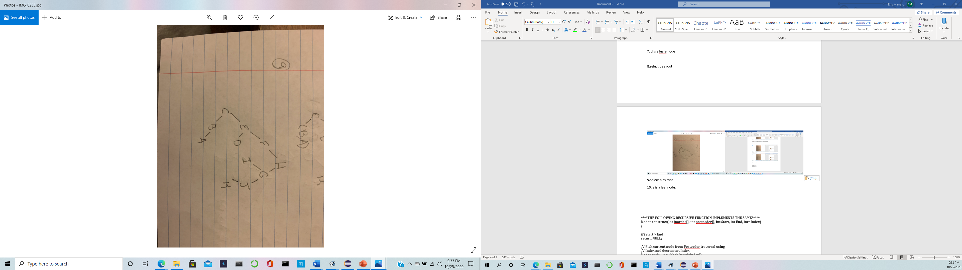

10. a is a leaf node.

**\*\*\*\*THE FOLLOWING RECURSIVE FUNCTION IMPLEMENTS THE SAME\*\*\*\*\***

**Node* construct(int inorder[], int postorder[], int Start, int End, int* Index)**  
**{**  
  
**if (Start > End)**  
**return NULL;**  
  
**// Pick current node from Postorder traversal using**  
**// Index and decrement Index**  
**Node* node = newNode(post[*Index]);**  
**(*Index)--;**  
  
**// If this node has no children then return**  
**if (Start == End)**  
**return node;**  
  
**//Else find the index of this node in Inorder**  
**// traversal**  
**int iIndex = search(in, Start, End, node->data);**  
  
**// Using index in Inorder traversal, construct left and**  
**// right subtress**  
**node->right = construct(inorder, postorder, iIndex + 1, End, Index);**  
**node->left = construct(in, post, Start, iIndex - 1, Index);**  
  
**return node;**  
**}**

